Dataset
Because the dataset is too large to upload to GitHub, the dataset link is provided below.
Original dataset address：
https://github.com/andreluizbvs/InsPLAD
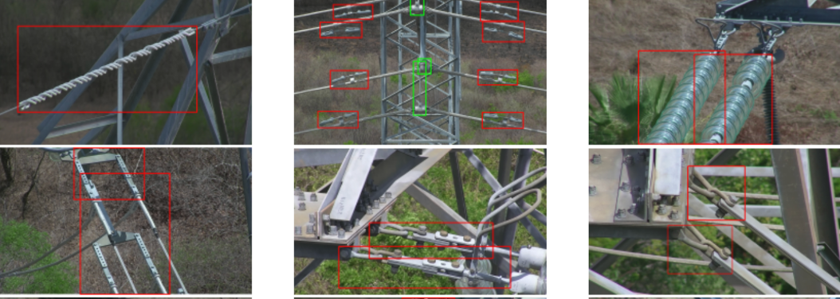
InsPLAD-det Dataset Diagram
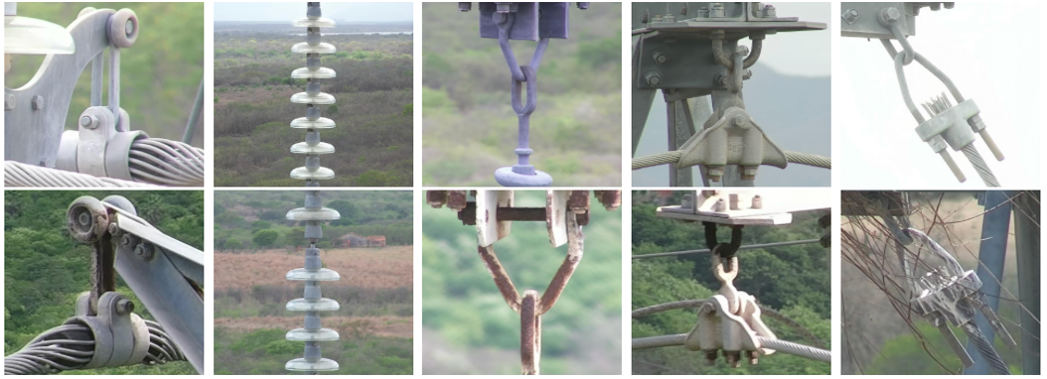
InsPLAD-fault Dataset Diagram
During the experiment, Roboflow was used to convert the dataset images to YOLO format, and data cleaning was also performed. The dataset address on the Roboflow official website is:
https://app.roboflow.com/yzt-rjegn/my-first-project-c0nlw/1
https://app.roboflow.com/yzt-rjegn/my-second-project-xb4il/1

